**Geometric Abstract Paintings**

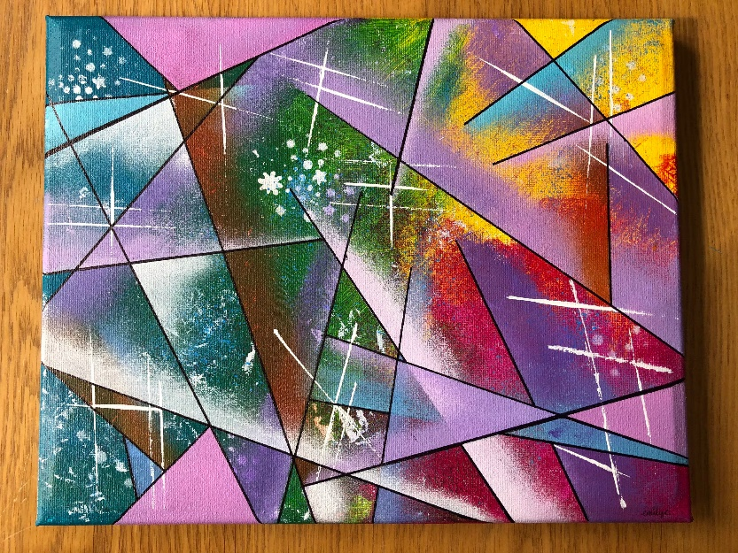Geometric abstract paintings are a visually striking form of modern art that uses geometric shapes, lines, and patterns to create compositions that are non-representational and open to interpretation. These paintings often incorporate a wide range of colors, textures, and forms—such as circles, triangles, squares, and rectangles—arranged in dynamic, often asymmetrical layouts. The emphasis is on balance, harmony, and visual interest, rather than on depicting recognizable objects. Ideal for contemporary interiors, these abstract pieces add a touch of sophistication and intrigue, making them perfect for living rooms, offices, or art galleries. The bold simplicity of geometric abstract paintings can evoke emotions, spark curiosity, and complement a wide range of design styles.